
Year 9

Semester 1 Exam

Resources allowed: Calculator and a handwritten A4 notes page double sided

Name: ______________________ Class: ______ Time: 50 minutes Total Marks: 50

- [5 Marks]
Simplify the following leaving your answers with positive indices.

- b)

- d)

2. [4 marks]

Simplify each of the expressions:

- $12j+3k-9j+k$ b) $7yz ×3z$

c) $20q-14pq+5p-qp$ d)$\frac{20bc}{25c}$

3. [4 Marks]

Expand and simplify each of the expressions:

- Expand and simplify
(i)$5(9g-4)$ ii) $8+ 7(10-3w)$

- Factorise
- 7x + 21 (ii) 20a²b – 15a

4. [2 marks]

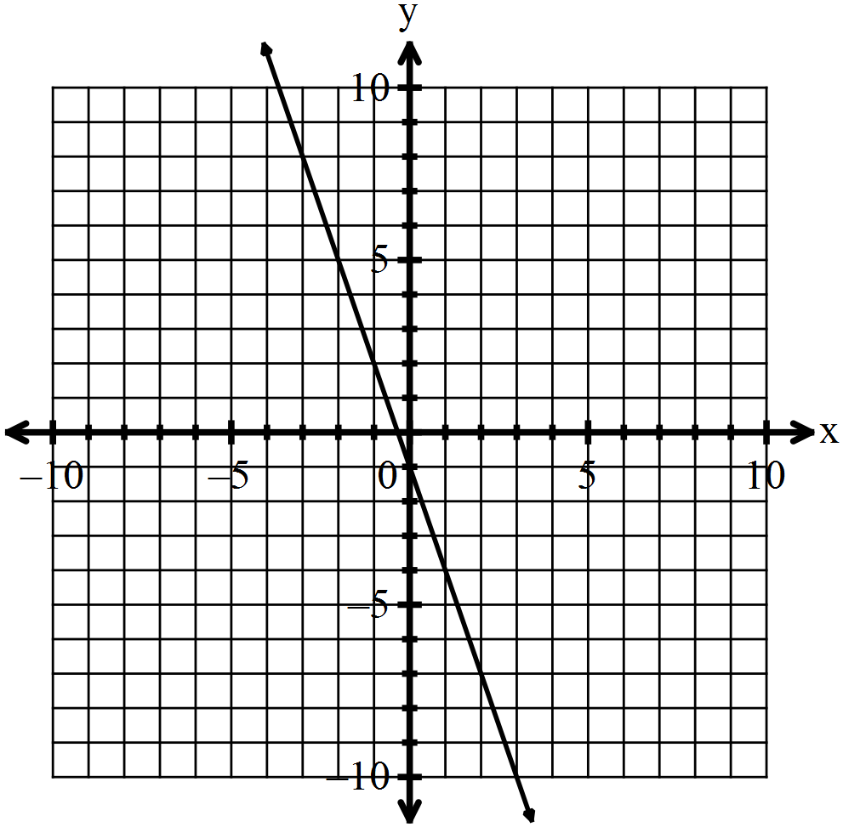Multiple choice: Circle your answer clearly
i. The slope of the given line is:
a) 3
b) -3
c)
d)

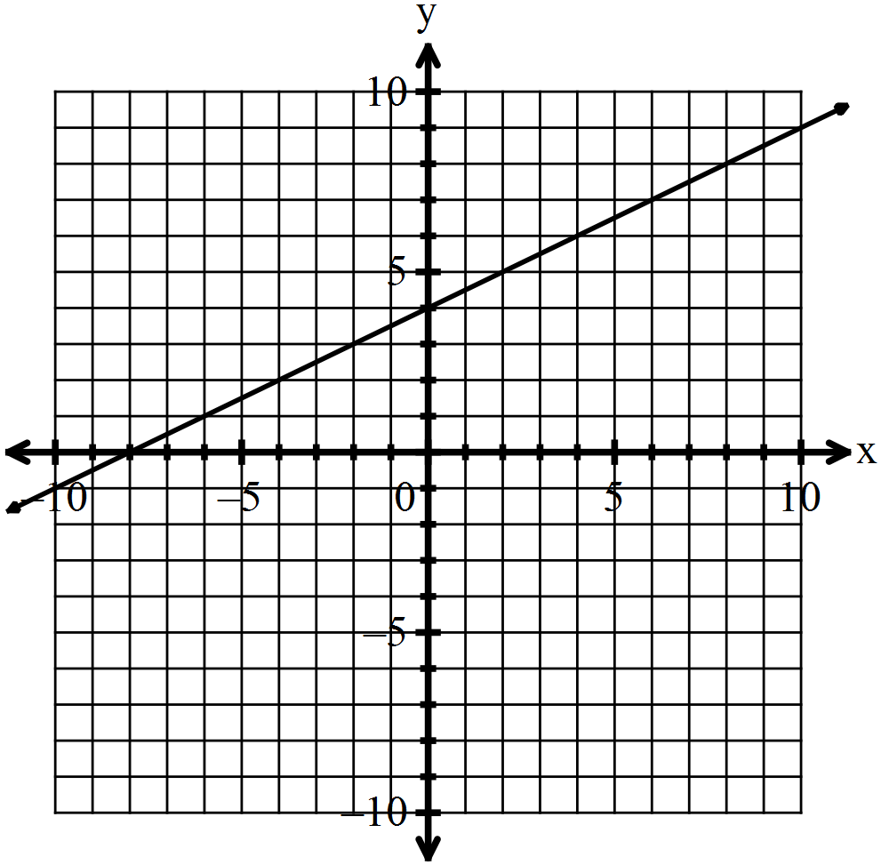 ii. The equation of the line is:
a)
b)
c)
d)

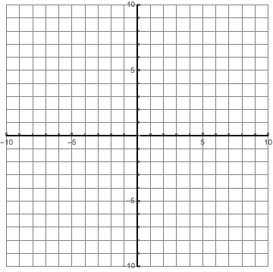
5. [3 Marks]

- Plot the two points

- Use Pythagoras to find the distance between the two points

6. [4 marks]

Find the surface area of the following solids:
(a)
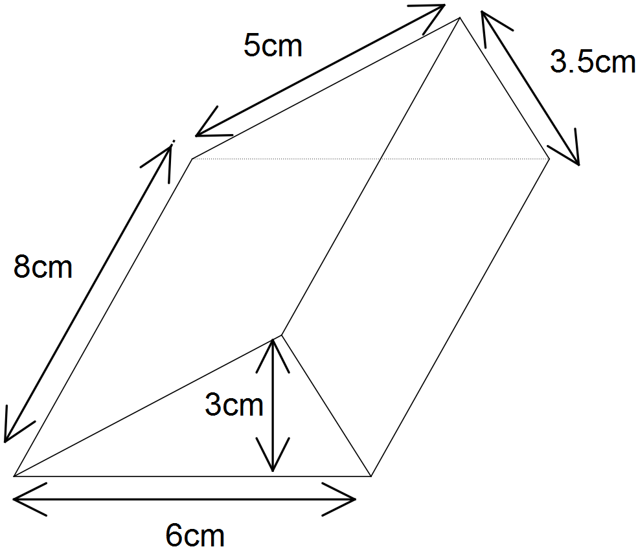

(b)
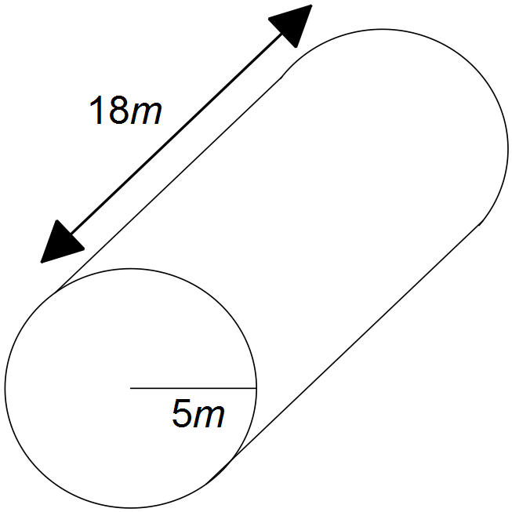

7. [3 Marks]

Write these ratios in their simplest form
a) 25 : 50 b) 50 c : $1 c) 12.5 : 10 : 5

8. [2 Marks]

350g of flour is to be divided into a ratio of 3:7 to be used in two different recipes. Find the smaller amount of flour.

9. [5 Marks]

Convert the following into rates with the units indicated
$250 in 5 hours | $__________ /hr
12 truckloads in 3 hours | _________ truckloads per hour
468 people per year | _________ people per week
2.5 kg of beef cost $15 | $__________ /kg
18 L in 2 hours | __________ mL/s

10. [3 Marks]

- 1 Australian dollar (1AUD) can be exchanged for 1.05 New Zealand dollars (1.05NZD). How many New Zealand Dollars could you get for 60 Australian Dollars?

- Tenaya is going on holiday and wants to buy a souvenir for her three best friends. Each one costs 6 New Zealand Dollars, and she only has 18 Australian dollars left. Can she afford these, and if so how much money in Australian dollars would she have left over?

11. [5 Marks]
- Complete the statements:

- Pythagoras’ theorem is only true for ________________________ triangles.

- The longest side of a right angled triangle is called the _________________.

- The sum of the squares of the __________________ sides of a right angled

triangle is equal to the square of the _____________________.

- Write an equation to show how the three sides of Triangle 1 relate to each other.
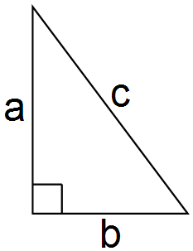

Triangle 1

- [7 marks]
Find the value of the variable in each of the following diagrams. Show your working giving accurate answers.
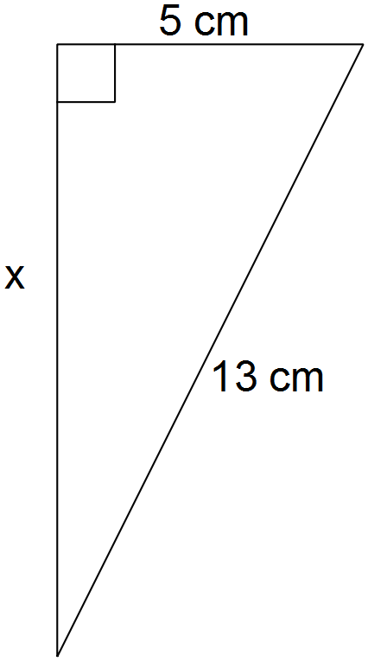  c) | 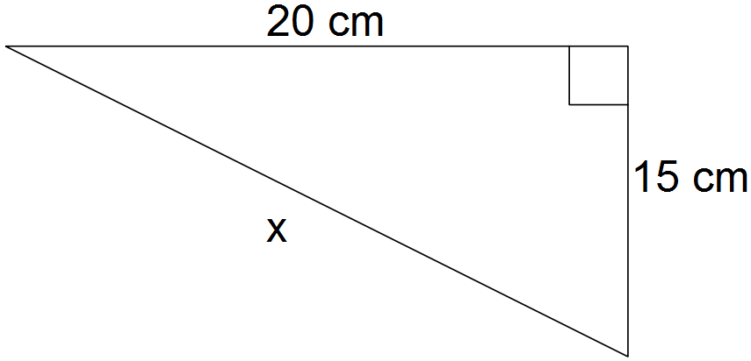
- [4 Marks]

John leaves his farm and is driving West at a speed of 80 km/hr for 1.5 hours. He then turns right and travels North for 45 minutes at a speed of 110 km/hr.

- How far did he travel to the North?

- How far did he travel to the West?

- His emergency radio has a range of 150km. Can he still send a message home? Show by how far he can or can’t.

